Enterprise Application Development Lab 3
Conor O’Brien C14733295

Queries:
Q2: Showing all the products.
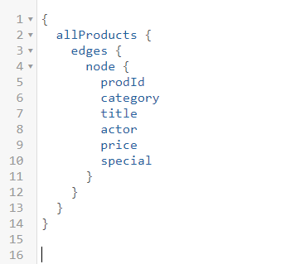
Output:
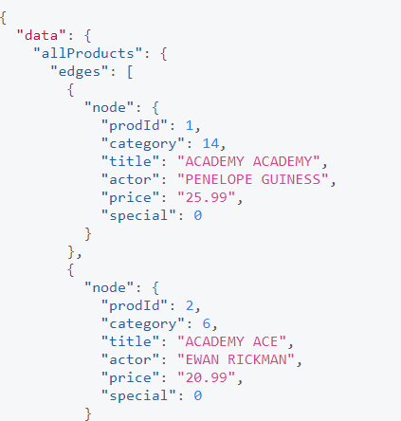

Q3
Showing the triple join:
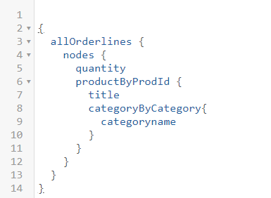

Output:
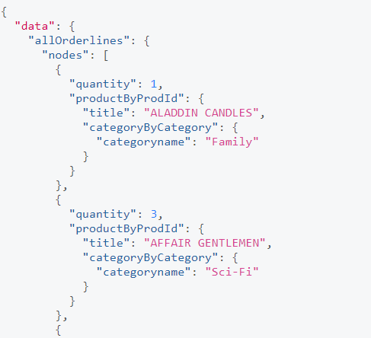
Q4:
My attempt at the mutation, couldn’t get it working.

mutation newOrder {
createOrder(orderid: 120000, orderdate: "2010-12-12-", customerid: 1, netamount: "50", tax: "5", totalamount: "55")
}

